

Design and Develop an Automated Data Anonymization Tool
SOI-2026-2610-0044

Date of Submission: 27-July-2026

Submitted By:

SOI-2026-0051
24014233 | Low Jin Shun
24008242 | Maxwell Nathaniel Ang
24003322 | Sarvezshvaran Sivakumar

ACKNOWLEDGEMENTS
We would like to acknowledge our FYP Supervisor, Nicole Cheong for the help she has given us to solve our problems.

TABLE OF CONTENTS

ACKNOWLEDGEMENTS 2
ABSTRACT 4
1 Introduction 5
2 Project Specification and Plan 6
2.1 Project Overview 6
2.2 Functional Requirements 6
2.3 Project Plan 7
3 Business Analysis 8
3.1 Business Issues 8
3.2 Market Analysis 8
3.3 Business Solutions 8
4 System Design and Implementation 9
4.1 System Architecture 9
4.2 Detailed System Design 9
5 System Testing 10
6 User and Technical Documentations 11
6.1 User Documentation/Guide/Manual 11
6.2 Technical Documentation (Installation guide/Manual) 11
6.3 Generative AI Usage Declaration 11
6.4 Git Repository 11
7 Conclusions 13
References 14
Appendices 15
Project Poster 16

ABSTRACT
The Project is about making a system that allows players to store their data securely for registering into tournaments for a game called Mobile Legends Bang Bang (MLBB). Employees can use the stored information to check player’s identity and make sure that the players are using the correct MLBB Account. We decided to make a website to implement this project, for storing of database we chose to use MySQL Database. This project allows players to have a piece of mind when entering their data, by allowing the employees to check the data means there will lesser cheating. The website is up and running, allowing players to enter their data to store it. The database is connected and when the data is inputted it will be encrypted and it will be decrypted when the data is being called by admin and employee role.

Introduction
Currently in Singapore there is a tournament for MLBB called MPL SG, for storing of data, they use Microsoft Excel to store and check for players’ data when registering them. This is very dangerous as the players’ data is not stored securely. Our project is meant to solve this issue, making it safe for the players to submit their information without worrying about their information being compromised. We want to have anonymization techniques in our website, and we also want to make sure that our website complies with Singapore Data Protection Frameworks like PDPA and PDPC. We design the website in a way that only authorised personal can access certain player data. For example, the player can only see and edit their own data and have no access to any other player’s data.

Project Specification and Plan

Project Overview
The benefit of this project allows the expansion of Singapore’s attention to esports, as in the past years the government decided to pay more attention to esports. Having a secure website prevents the tournament from having any legal issues as it is compliant. The website allows players to be confident that their data will not be leaked and is safe. The project consists of making a website and database, making sure that there are anonymization techniques in build on the website and that there is an area for players to show their consent for storing their data on the website to comply with PDPA/PDPC.

Functional Requirements
making sure that there are anonymization techniques in build on the website and that there is an area for players to show their consent for storing their data on the website to comply with PDPA/PDPC. There are different roles for different stages of permission to access certain data.
The system also requires operational controls that support daily use of the website. The audit log must record important user actions and allow administrators to review activity. Repeated failed logins must create suspicious-activity alerts. Player registration must detect duplicate records, enforce team-capacity limits, and prevent duplicate MLBB roles within a team. Inactive users must be logged out automatically with a clear notification. Administrators must be able to monitor system health, create and restore backups, and use a role-based AI chatbot that gives helpful website guidance to Public Users, Players, Employees, and Admins.

Project Plan
Low Jin Shun:
Task | Progress
Design Data Flow Diagram | 100%
Setting Up Website | 100%
Implementing Anonymization Techniques | 100%
Design Website UI | 100%
Making Statistics Graph | 100%
Implement Image Processing | 100%
Research On Frameworks | 100%
Finding Case Study | 100%
Documentation and Report Writing | 50%
Implement Consent Feature | 100%

Maxwell Nathaniel Ang:
Task | Progress
Design Security And System Diagram | 100%
Setting Up Database | 100%
Implementing Anonymization Techniques | 100%
Link thing | 100%
Changing website to HTTPS | 100%
Research On Frameworks | 100%
Documentation and Report Wrinting | 50%

Sarvezshvaran Sivakumar:
Task | Progress
Implementing Audit Logs | 100%
Implementing AI Chatbot | 100%
Implementing Back Up | 100%
Making the Poster | 100%
Implementing Backup and Recovery | 100%
Creating Poster | 100%
Preparing Documentation and Slides | 100%
Implementing Suspicious Login Activity Alerts | 100%
Implementing Smart Duplicate Player Detection | 100%
Implementing Automatic Session Timeout | 100%
Adding Inactivity Logout Notification | 100%
Implementing System Health Monitoring | 100%
Implementing Team Capacity and Role Validation  Fixing Dark and Light Mode Appearance | 100%
Correcting Singapore Date and Time Display | 100%
Implementing Suspicious Login Activity Alerts | 100%
Website Testing, Debugging and Error Fixing | 100%
Implementing Automatic Session Timeout | 100%

Business Analysis

Business Issues
MPL Singapore currently uses Microsoft Excel to store and check player registration data. This is risky because the data contains sensitive details such as age, phone number, identity information, address, email, game account details, and consent records. Without anonymisation, the original personal data may be exposed if the file is leaked or wrongly shared.
The key business issue is to use player data for registration and verification without revealing more personal information than needed. The system must protect sensitive data while still allowing staff to check identity, eligibility, and game account ownership.
Access control is also important. Players should only view and edit their own data, while staff should only see the fields needed for their role. Anonymisation reduces the impact even if unauthorised access happens.
Manual registration is slow and hard to audit. As the tournament grows, the organiser needs a safer system that can protect data automatically instead of depending on manual handling.

Market Analysis
The esports market in Singapore is growing, and tournaments such as MPL Singapore need to manage more player data securely. This increases the need for systems that can protect personal data while still supporting registration and verification.
The target users include tournament organisers, administrators, team managers, players, and support staff. These users need a platform that can collect player data, hide or transform sensitive fields, and only show the required information to authorised users.
Compared with spreadsheets, a web-based system is more suitable because anonymisation can be built into the process. This makes the solution safer and more scalable for future tournament seasons.

Business Solutions
The proposed solution is a secure web-based registration and player management system with anonymisation as a core feature. Players can register, give consent, and update their own details. Staff can verify players without exposing unnecessary personal data.
When a player submits registration details, the system records consent and applies suitable protection to sensitive fields. If the player is below 18 years old, the system also requests parental permission.
Different anonymisation methods are used based on the type of data. For example, emails are masked, age is generalised into a range, phone numbers and identity information are encrypted, addresses are tokenised, date of birth is masked, server ID is protected using differential privacy, and region data is swapped for statistics.
These methods allow the organiser to still use the data for verification, eligibility checks, communication, and reporting, while reducing the risk of exposing the original personal data.
The solution also improves operational control. Audit logs provide a trace of important actions, suspicious-login alerts help administrators identify repeated failed access attempts, and duplicate detection reduces inaccurate player records. Backup and recovery functions support restoration if data is lost, while system-health monitoring helps administrators check whether the database and application are available. The n8n AI chatbot gives role-based assistance on how to use the website, reducing repeated support questions and helping users navigate the correct pages and functions.

System Design and Implementation

System Architecture
The website is made by using JavaScript and html, by using MySQL Database, the website will be able to store and call for data from the database.

The system uses a Node.js and Express application layer to process requests from the website interface. MySQL stores player, team, account, consent, audit, alert, approval, retention, and backup information. The built-in chatbot sends the user’s question, role, username, and session identifier to an n8n Webhook. The n8n AI Agent uses an OpenRouter chat model and Simple Memory to prepare a role-appropriate reply, which is returned to the website through a Respond to Webhook node. The website also contains service modules for audit logging, team rules, backup handling, Singapore time, and chatbot requests.

Detailed System Design
Data Flow Diagram:
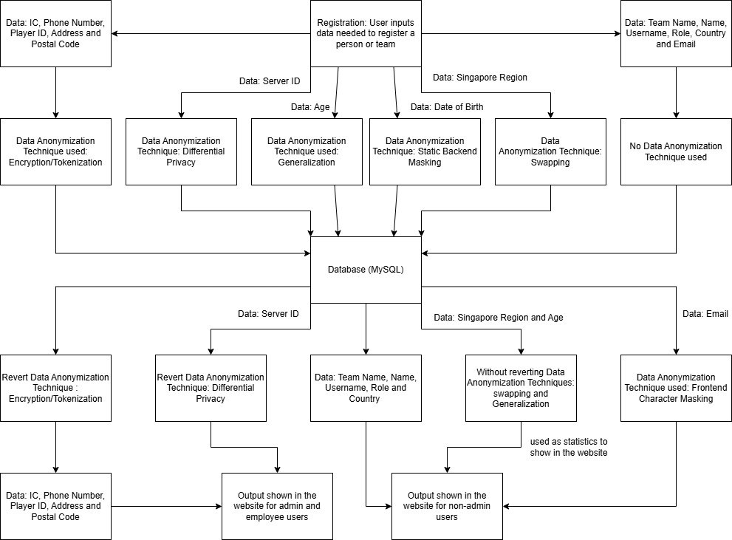
Role-Based Access:
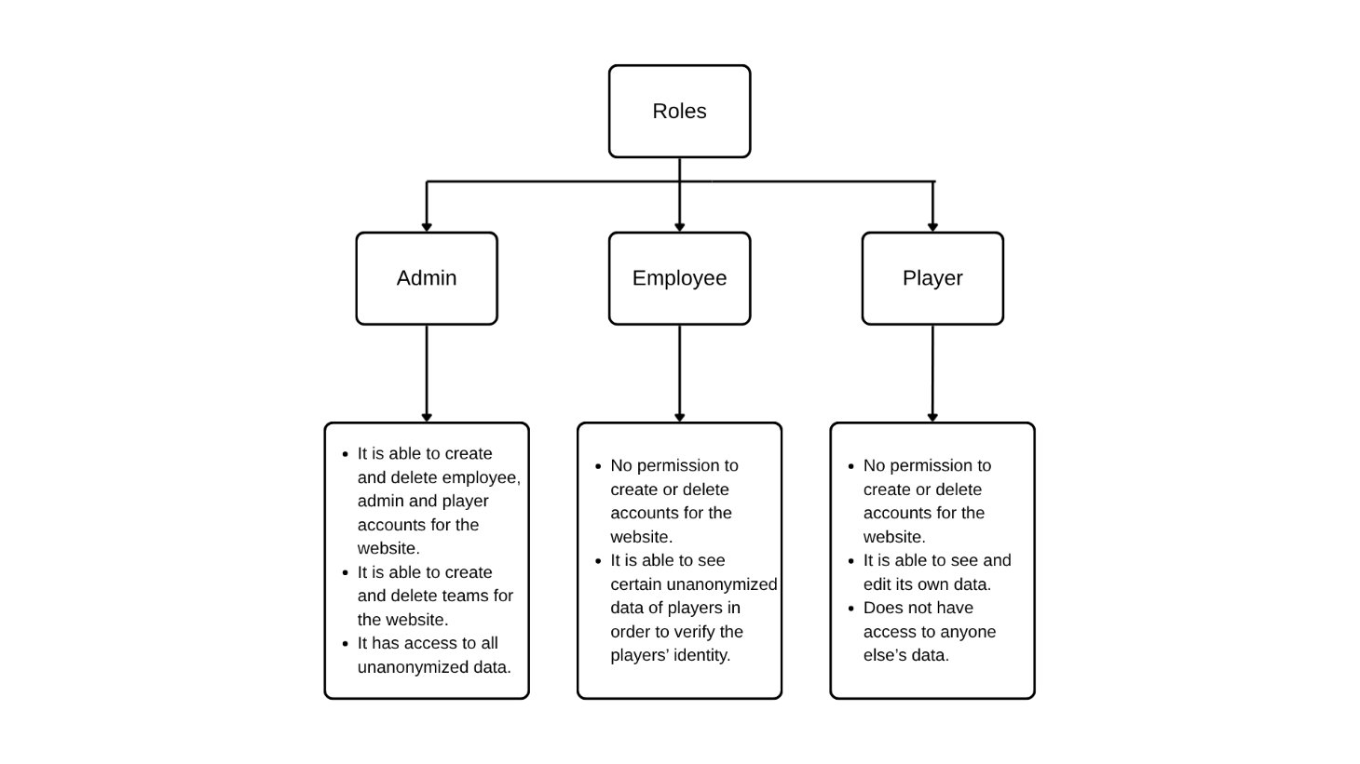Security diagram:
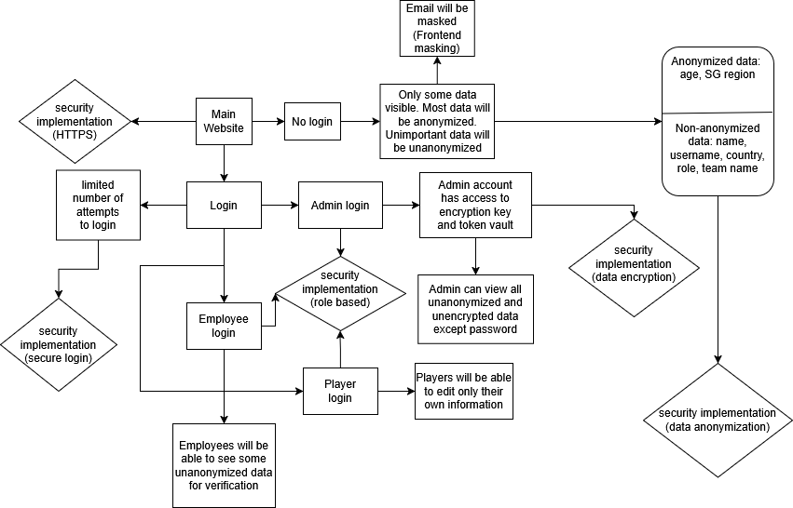System diagram:
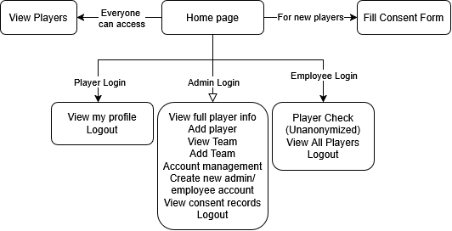

System Diagram:

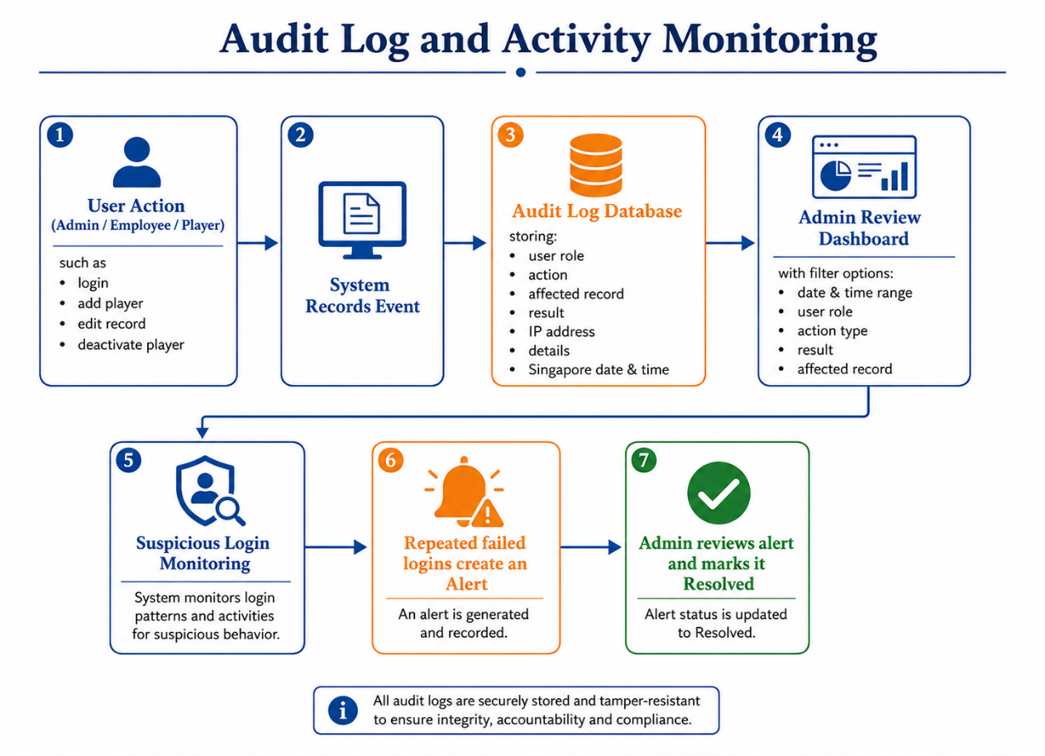

Audit Log and Activity Monitoring: Important actions are recorded with the user role, action, affected record, result, IP address, details, and Singapore date and time. Administrators can filter the audit log and review suspicious login alerts. Repeated failed logins create an alert that can be reviewed and marked as resolved.

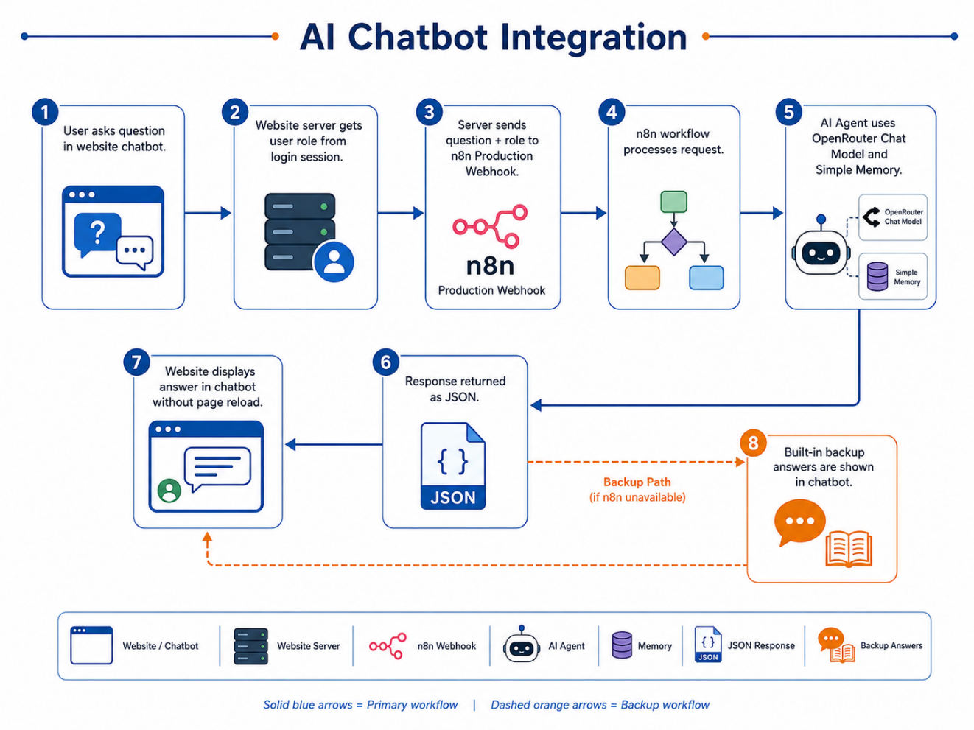

AI Chatbot Integration: The chatbot is available inside the website. The server obtains the user role from the login session and sends the question to the n8n production Webhook. n8n processes the message using an AI Agent, OpenRouter Chat Model, and Simple Memory. The response is returned as JSON and displayed in the chatbot without reloading the page. If n8n is unavailable, the system can display built-in backup answers.

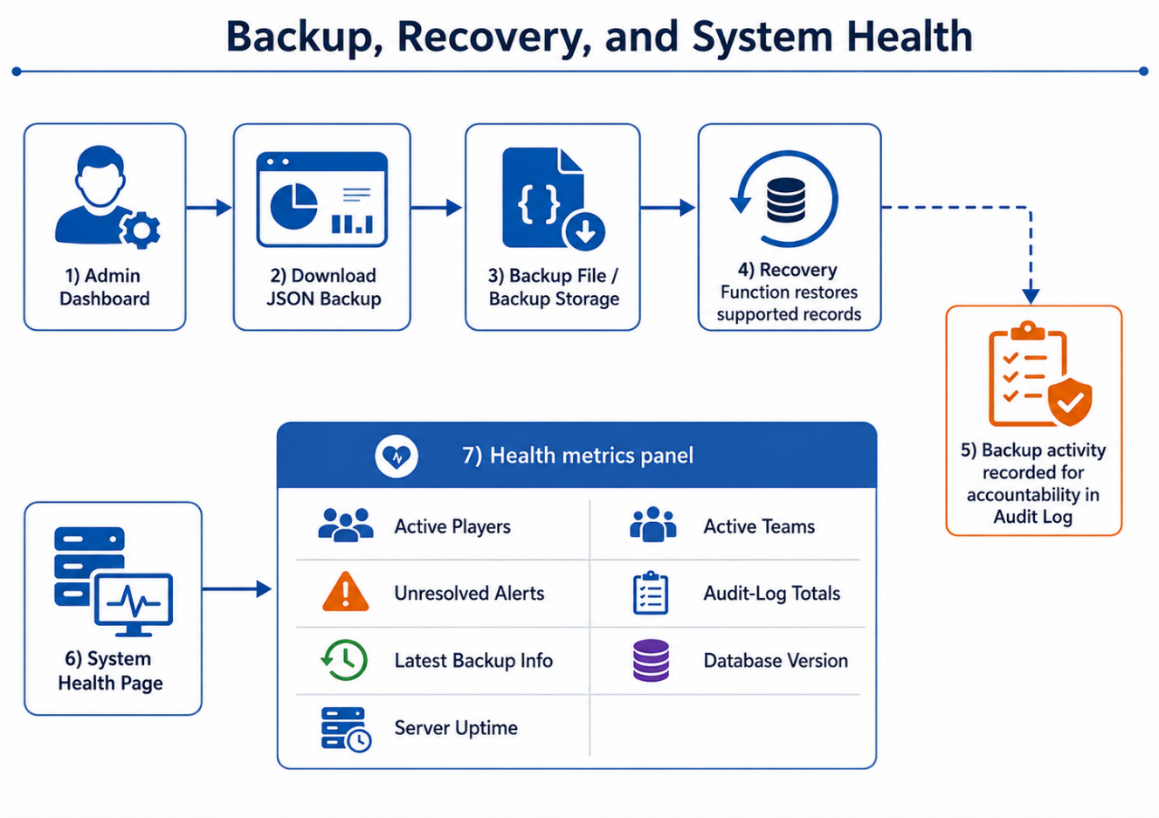

Backup, Recovery, and System Health: Administrators can download a JSON backup and restore supported records through the recovery function. Backup activity is recorded for accountability. The system-health page displays key information such as active players, active teams, unresolved alerts, audit-log totals, latest backup information, database version, and server uptime.

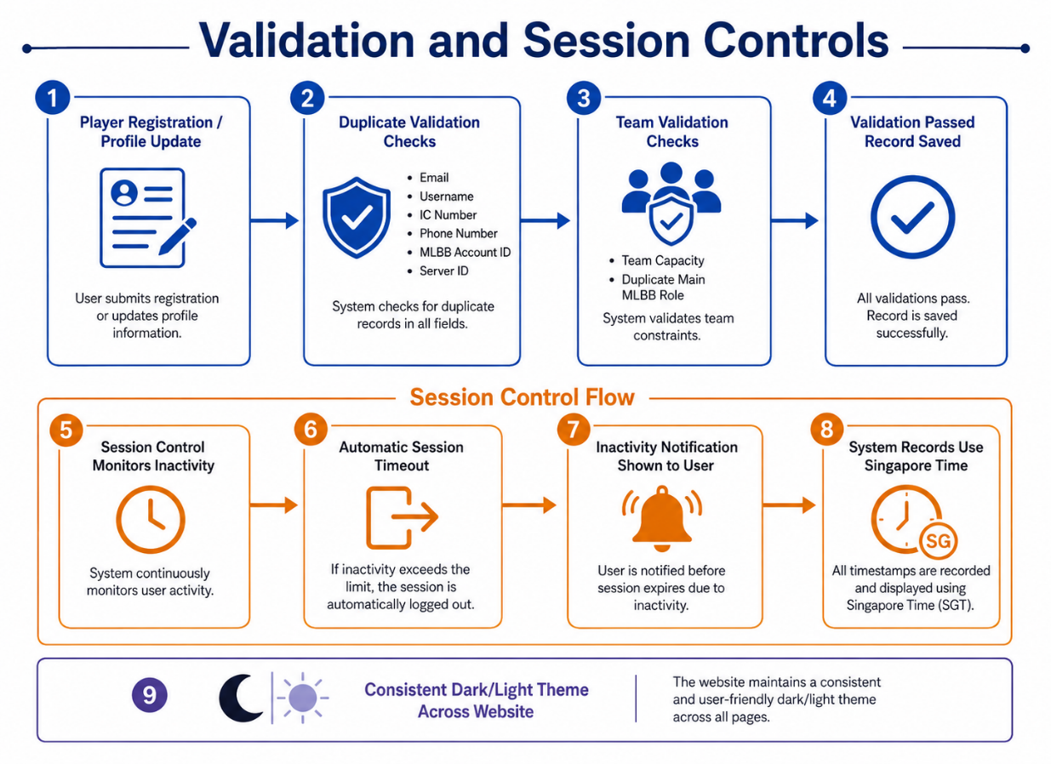

Validation and Session Controls: The registration process checks duplicate emails, usernames, IC numbers, phone numbers, MLBB Account IDs, and Server IDs. Team-capacity and role validation prevent a full team or duplicate main MLBB role from being selected. Automatic session timeout logs inactive users out and displays an inactivity notification. Singapore time is used for system records, and the dark/light theme is kept consistent across the website.

Role | Main access | Restriction
Public User | Homepage, public players, consent and login | No private records or management pages
Player | Own profile, edit permitted fields, view public players | Cannot view or change another player
Employee | Player Check, permitted records, approval requests | Cannot approve own sensitive request or use Admin-only functions
Admin | Full management, audit, alerts, access review, retention, backup and health | Sensitive operations are logged and validated

System Testing
Section Explanation: This section describes how the system will be tested for robustness and fulfilment of functional and system requirements (Test Plan).

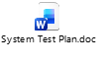

Functional testing was carried out on the features implemented for system monitoring, user support, validation, and recovery. Each test was performed using the appropriate role account and the result was compared with the expected behaviour.

Feature Tested | Test Procedure | Expected Result | Status
Audit Log | Perform an Admin action and open Audit Log. | The action is recorded with role, status, details, IP address, and Singapore time. | Pass
Suspicious Login Alert | Enter an incorrect password repeatedly for the same account. | A high-severity alert is created after the configured failed-login threshold. | Pass
Duplicate Detection | Register a player using an existing email, username, IC, phone, Account ID, or Server ID. | Registration is blocked and the duplicate reason is shown. | Pass
Session Timeout | Remain inactive for the configured 1 minute 30 seconds. | The user is logged out and receives an inactivity message. | Pass
Team Capacity | Add or move a player into a full team. | The update is rejected because the team has reached its maximum capacity. | Pass
Role Validation | Assign a player to a main MLBB role already used in the same team. | The system rejects the duplicate role. | Pass
Backup and Recovery | Download a backup and restore a valid backup file. | The backup is created and supported missing records can be recovered. | Pass
System Health | Open the System Health page while the database is available. | Database status, uptime, counts, alerts, and backup details are displayed. | Pass
n8n AI Chatbot | Log in as Admin and ask how to add a new player. | n8n receives the Admin role and returns role-based step-by-step website guidance. | Pass
Theme and Time | Switch dark/light mode and review dated records. | The layout remains readable and records use Singapore date and time. | Pass

Other Resources for reference on Software Debugging and Testing:
https://en.wikipedia.org/wiki/Software_testing
https://braydie.gitbooks.io/how-to-be-a-programmer/content/
http://www.extremeprogramming.org/rules/unittests.html

User and Technical Documentations

User Documentation/Guide/Manual
A user documentation or manual should be produced to describe how the system should be used. It should be readable and understandable by a non-technical person (i.e. someone who is IT illiterate). Illustrations and graphics can be used to great advantage here.

Using the AI Chatbot: Click the AI Help button at the bottom-right of the website, type a question, and press Send. The chatbot uses the logged-in role to provide relevant instructions. For example, an Admin can ask how to add a player, while a Player can ask how to edit their own profile.

Admin Monitoring and Recovery: Administrators can open Audit Log to review system activity, Suspicious Activity to review alerts, System Health to check the application and database, and Backup and Recovery to download or restore supported records.

Registration and Team Validation: When registering or editing a player, users must select an available team and MLBB role. If the team is full, the role is already occupied, or duplicate player details are detected, the system displays an error, and the information must be corrected before submission.

Technical Documentation (Installation guide/Manual)
First download the code from the GitHub in the link bellow.
Second make sure that all the modules required are downloaded.
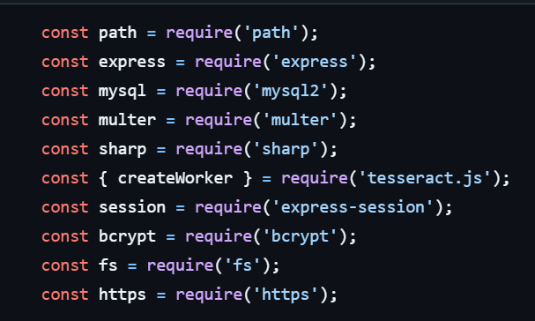“npm install (module name)”
Use “node app.js” to run the website in the terminal.

Generative AI Usage Declaration
Generative AI tool used | How the output was used
GitHub Copilot AI | Used for troubleshooting within the code on the website
Chatgpt | Used for troubleshooting, flow guidance
OpenRouter Chat Model through n8n | Used by the website chatbot to generate role-based guidance

Git Repository
Section Explanation: Provide the URL to this FYP project hosted in GitHub or GitLab. Students should have used GitHub or GitLab to host their code repository. They should have added the user SOI-Project or email Gen.SOI-Project@rp.edu.sg as a collaborator.
The instruction to do that in GitHub is at Inviting collaborators to a personal repository - GitHub Docs .
The instruction to add owner to your GitLab project is Members of a project | GitLab Docs.
GitLab Screenshot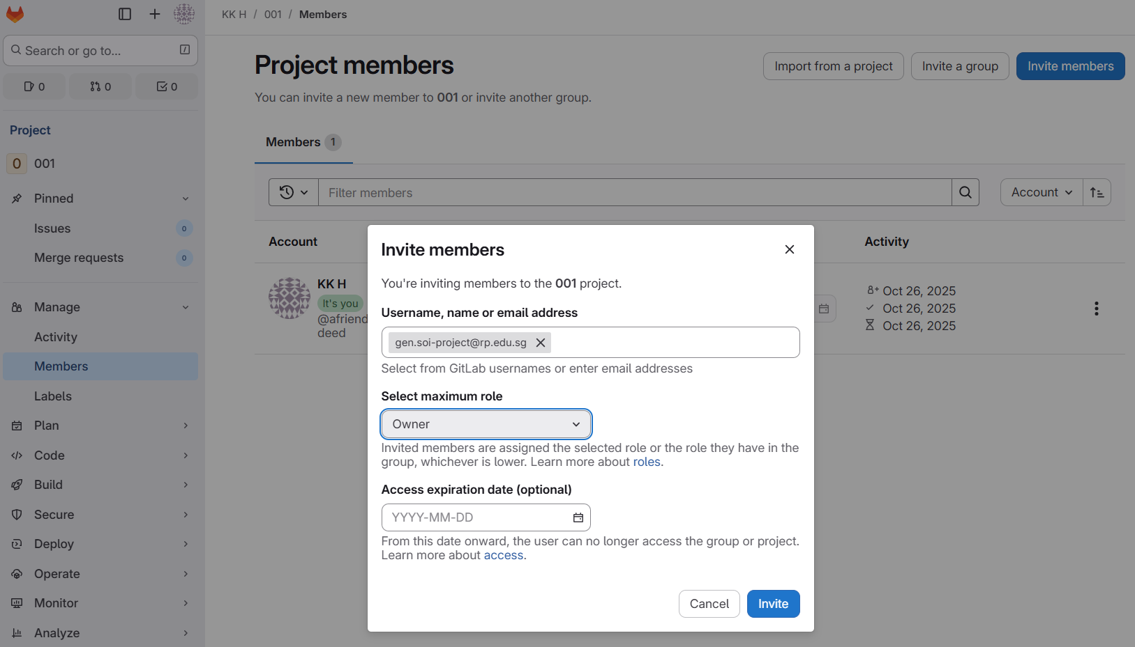
Git URL: https://github.com/itouchfrogs/FYP

Conclusions
As a team, we managed to make a functioning website, we added functions like consent forms statistics bar, data storage using anonymization techniques. We added different roles for different levels of access of data. The roles are Player, Employee, Admin. Player can only access their own data, Employee can access to specific player’s data in order to check the players. Admin can access everything to make sure that the website is running smoothly. There are multiple data anonymization techniques used, it is used to make sure that the players’ data is safely kept without compromising any of the players’ data. We made sure that when the players’ actual data is needed, the data is reverted to make sure that the data is correct. Some problems we had: There was a lot of miscommunications within the team causing a lot of unnecessary changes to the project. It could have been avoided if the team had better communication there would not have been this many changes resulting in the waste of time. In the future we need to make sure that everyone in the team is on the same page before moving onto another phase of the project.

The completed system also includes operational features that improve reliability and usability. The audit log and suspicious-login alerts support monitoring, while smart duplicate detection, team-capacity checks, and role validation improve registration accuracy. Automatic session timeout protects unattended accounts, and backup, recovery, and system-health functions support administrators in maintaining the platform. The n8n AI chatbot provides immediate role-based website guidance. Together, these additions make the platform more practical for tournament operations while keeping sensitive actions under the control of authorised users.

References
Case Study for reasoning of the project:
Thai esports player Tokyogurl arrested after cheating at 33rd SEA Games

How to use SSL/TLS with Node.js ? - GeeksforGeeks

Appendices

Appendix A: Role-Permission Matrix
Function | Public | Player | Employee | Admin
View public players | Yes | Yes | Yes | Yes
View own profile | No | Yes | No | Yes
Edit own profile | No | Yes | No | Yes
View permitted player check | No | No | Yes | Yes
Add or deactivate players | No | No | Request only | Yes
Manage teams and staff accounts | No | No | No | Yes
Review audit logs and alerts | No | No | No | Yes
Approve sensitive requests | No | No | No | Yes
Backup, recovery and system health | No | No | No | Yes

Appendix B: n8n Workflow Evidence
The chatbot workflow uses Webhook, Edit Fields, AI Agent and Respond to Webhook as the main path. The OpenRouter Chat Model and Simple Memory connect beneath the AI Agent.

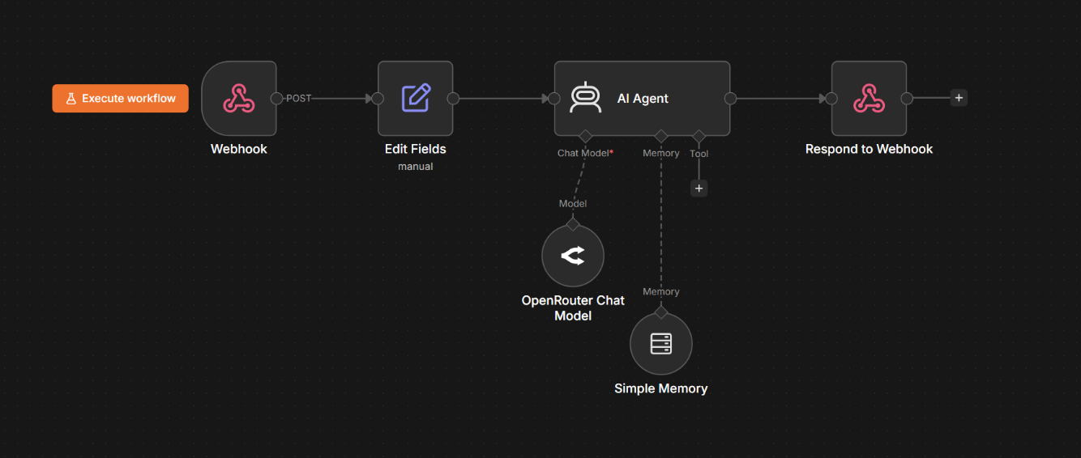

Appendix C: Chatbot Request and Response Format

{
"message": "How do I add a new player?",
"role": "admin",
"sessionId": "generated-session-id",
"username": "Admin"
}

Response:
{
"success": true,
"reply": "Open the Admin Dashboard and select Add Player..."

Appendix D: Final Completion Checklist

Item | Status
Core registration, consent and role access | Completed
Anonymisation methods and protected data display | Completed
Audit logs and suspicious-login alerts | Completed
Duplicate, team-capacity and role validation | Completed
Session timeout, Singapore time and theme consistency | Completed
n8n role-based AI chatbot and fallback answers | Completed
Backup, recovery and system health | Completed
Testing, user guide, technical guide and poster | Completed

Project Poster
